171805020 Yusuf AKIN

1-) Source IP= 192.168.1.102 TCP PORT= 1161

2-)Destination IP=128.119.245.12 TCP PORT = 80

3-) Empty



4-) Sequence Number=0 and ,the Syn flag is set to 1 which indicates that this segment is a SYN segment.

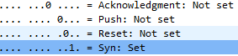

5-) Sequence Number=0 ACK=1 because gaia.cs.umass.edu acknowledged requested.

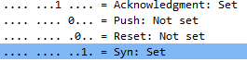

6-) Sequence Number=1



7-)

Segment 1 sequence number is 1

Segment 2 sequence number is 566

Segment 3 sequence number is 2026

Segment 4 sequence number is 3486

Segment 5 sequence number is 4946

Segment 6 sequence number is 6406

Time=0,026477 ACK time=0,053937 RTT =0,027460

Time=0,041737 ACK time=0,077294 RTT =0,035557

Time=0,054026 ACK time=0,124085 RTT =0,070059

Time= 0,054690 ACK time=0,169118 RTT =0,114428

Time=0,077405 ACK time=0,217299 RTT =0,139894

Time=0,078157 ACK time=0,267802 RTT =0,189645

Estimated RTT1= 0,027460

Estimated RTT2= (0,027460)\*0,875 + 0,125\* 0,035557=0,0284721

Estimated RTT3=(0,0284721)\*0,875+0,125\*0,070059=0,0336704

Estimated RTT4=(0,0336704)\*0,875+0,125\*0,114428=0,0437651

Estimated RTT5=(0,0437651)\*0,875+0,125\*0,139894=0,0557774

Estimated RTT6=(0,0557774)\*0,875+0,125\*0,189645=0,0725108

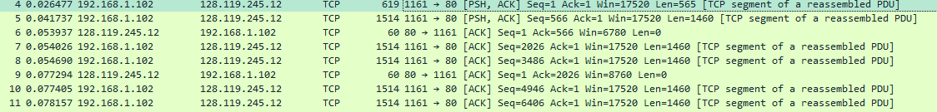

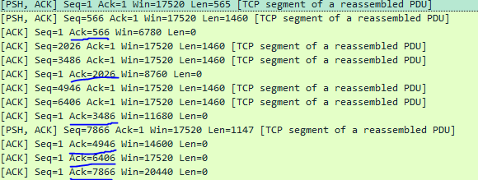

8-) 1-)565 bytes

2-)1460 bytes

3-)1460 bytes

4-)1460 bytes

5-)1460 bytes

6-)1460 bytes

9-)5840 The sender is never throttled.

10-)No, I checked time sequenced number(steven) graphed and all sequences increases continuosly.

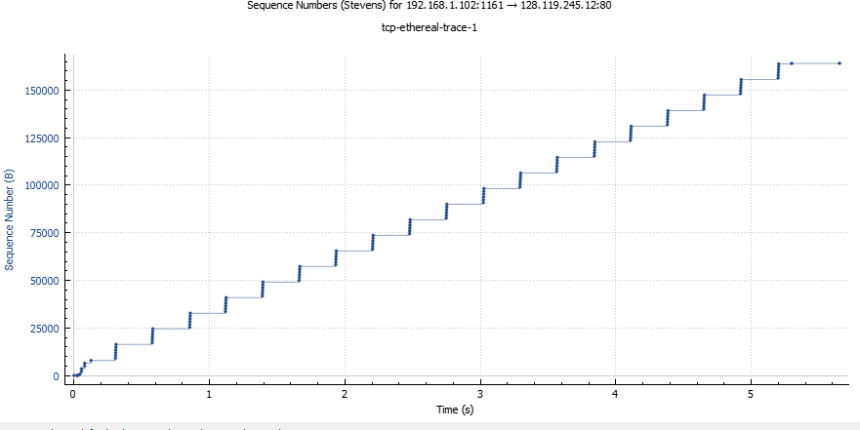

11-)The difference between the sequence number of two consecutive ACKs represents the data received by the server. For example here is 1460.

12-)5.651141s-0,026477s=5,624664s(Last ACK)-(First SYN ACK)

Download Time=(Finish Download)-(Start Download)

152136/5,624664=27048,01 bytes/sec (Data Length/Download Time) is throughput.

13-) Empty

14-) Empty